**Relative vs. Absolute Positioning in CSS:**

* **position: relative;**

An element with position: relative; is positioned relative to its normal position.

Setting the top, right, bottom, and left properties of a relatively-positioned element will cause it to be adjusted away from its normal position. Other content will not be adjusted to fit into any gap left by the element.

**Example:**



* **position: absolute;**

An element with position: absolute; is positioned relative to the nearest positioned ancestor (instead of positioned relative to the viewport, like fixed).

However; if an absolute positioned element has no positioned ancestors, it uses the document body, and moves along with page scrolling.

**Note:** A "positioned" element is one whose position is anything except static

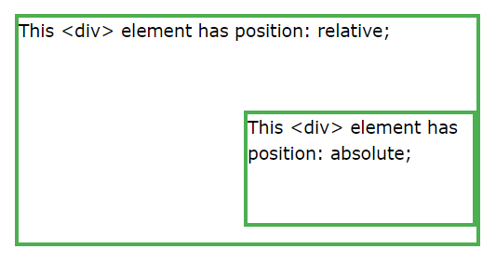**Example:**

**CSS Box Sizing: Margin vs. Padding:**

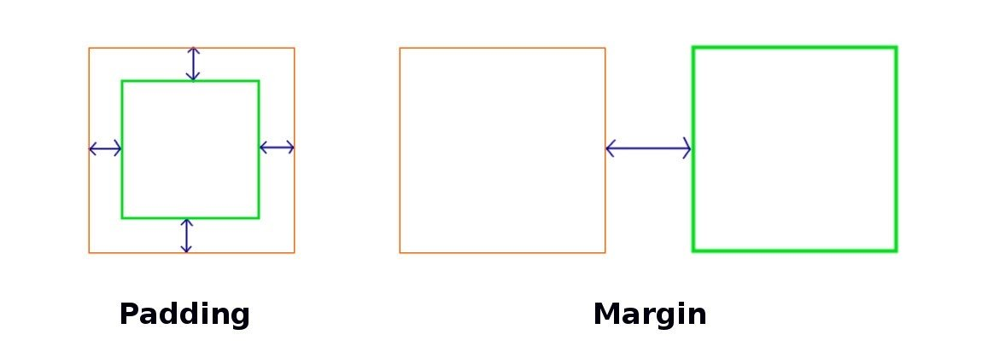Basically, a margin is the space around an element and padding refers to the space between an element and the content inside it.

The margin falls outside two adjacent elements. Each side of the element has a margin size you can change individually. In creating the gap, the margin pushes adjacent elements away.

On the other hand, padding is placed inside the border of an element. To create the gap, the padding either grows the element’s size or shrinks the content inside. By default, the size of the element increases.

If you want to create the gap by shrinking the content, set the **box-sizing** property value to **border-box** (i.e. **box-sizing: border-box**).